HTML stands for Hypertext Markup Language, and it is the most widely used language to write Web Pages.
- Hypertext refers to the way in which Web pages (HTML documents) are linked together. Thus, the link available on a webpage is called Hypertext.
- As its name suggests, HTML is a Markup Language which means you use HTML to simply "mark-up" a text document with tags that tell a Web browser how to structure it to display.

Basic HTML
<!DOCTYPE html>
<html lang="en">
<head>
<title>My First HTML Page</title>
</head>
<body>
<h1>Hello, World!</h1>
<p>This is a basic HTML document.</p>
</body>
</html>
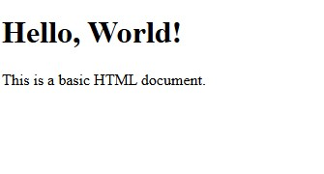

HTML Tags
HTML is a markup language and makes use of various tags to format the content. These tags are enclosed within angle braces . Except few tags, most of the tags have their corresponding closing tags.
Tag | Meaning / Purpose
<!DOCTYPE html> | Declares the document type and version of HTML (HTML5 in this case).
<html lang="en"> | Root element of the HTML document. lang="en" specifies the language as English.
<head> | Contains meta-information about the document (not visible on the page).
<title> | Sets the title of the web page (shown in browser tab or window title).
<body> | Contains the visible content of the web page.
<h1> | Displays a top-level heading (largest size).
<p> | Displays a paragraph of text.

Heading Tags
- HTML headings are titles or subtitles that you want to display on a webpage.
- HTML headings are defined with the <h1> to <h6> tags.
- <h1> defines the most important heading. <h6> defines the least important heading.
- Search engines use the headings to index the structure and content of your web pages.

Example
<!DOCTYPE html>
<html>
<body>
<h1>Heading 1</h1>
<h2>Heading 2</h2>
<h3>Heading 3</h3>
<h4>Heading 4</h4>
<h5>Heading 5</h5>
<h6>Heading 6</h6>
</body>
</html>
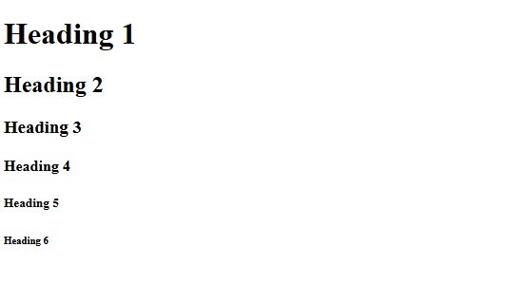

Use of Comments in HTML
Comments in HTML are used to leave notes or explanations in the code that are not displayed in the browser.
Why use comments?
- To explain the purpose of code (for yourself or other developers)
- To temporarily disable code without deleting it • To organize sections of your HTML document
- To make the code more readable and maintainable.
Syntax of an HTML Comment:
<!-- This is a comment -->

Examples
<!DOCTYPE html>
<html lang="en">
<head>
<title>My First HTML Page</title>
</head>
<body>
<!-- This is the main header section -->
<h1>Welcome to My Website</h1>
<!--<p>This line is commented out and won’t appear on the page</p> -->
<!—links are here -->
<a href="#">Home</a>
<a href="#">About</a>
</body>
</html>

Output
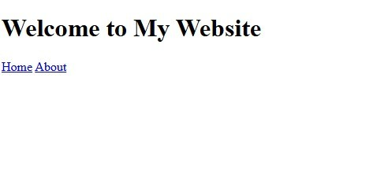

Text Styling in HTML
HTML provides several tags for styling text, such as <strong> for bold text, <em> for italic text, and <u> for underlined text.

Basic Text Styling Tags
- <b>
Use :Makes text bold
<b>This is bold text</b>

- <i>
Use:Makes text italic
<i>This is italic text</i>
- <sub> and <sup>
Use : <sub> creates subscript (used in chemical formulas).
<sup> creates superscript (used in math or footnotes). H<sub>2</sub>O <!-- Displays: H₂O --> mc<sup>2</sup><!-- Displays: E = mc² -->
- <br>
Use : Inserts a line break
Line one<br>Line two
<!DOCTYPE html>
<html>
<body>
<b>This is bold text</b>
<i>This is italic text</i>
Line one<br>Line two
H<sub>2</sub>O <!-- Displays: H₂O --> mc<sup>2</sup><!-- Displays: E = mc² -->
</body>
</html>
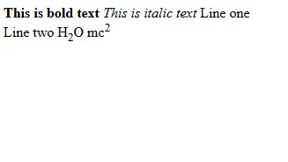
Images:
Images can be added to an HTML document using the <img> tag. The src attribute is used to specify the URL of the image file, and the alt attribute is used to provide a text description of the image for acce ssibility purposes.
<imgsrc="pic_trulli.jpg" alt="Trulli" width="500" height="333">
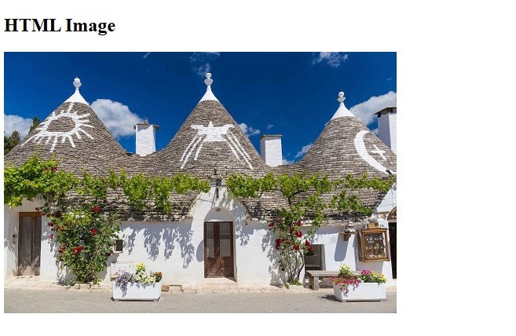
Note that the <img> tag does not have a closing tag and is an empty element, meaning it does not have a closing tag.

Basic Text Formatting Tags in HTML
Tag | Description
<b> | Bold text (non-semantic)
<strong  > | Important/bold text (semantic)
<i> | Italic text (non-semantic)
<em> | Emphasized/italic text (semantic)
<u> | Underlined text
<small> | Smaller text
<mark> | Highlighted text
<sup> | Superscript (e.g., x2)
<sub> | Subscript (e.g., H2O)

HTML Symbol Entities
Symbols or letters that are not present on your keyboard can be added to HTML using entities.
For example, if you want to display a copyright symbol "©", you should use either &#169; or &copy; in your code.
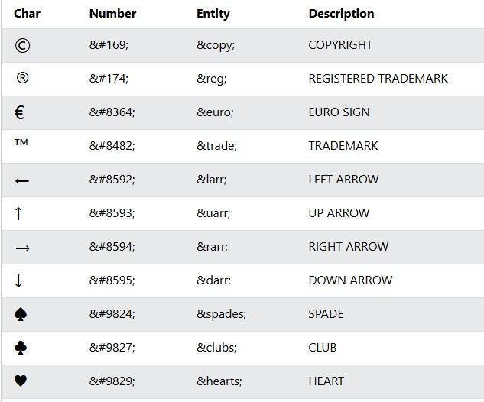
<!DOCTYPE html>
<html>
<body>
<h1>HTML Entity Example</h1>
<h2>The copyright symbol: &copy;</h2>
<h2>The arrow-left symbol: &larr;</h2>
<h2>The black-spade-suit symbol: &spades;</h2>
</body>
</html>
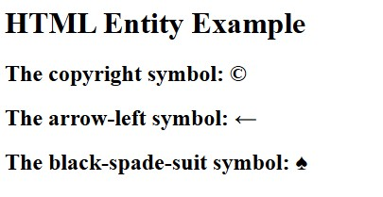

HTML <hr> Tag
The <hr> element is most often displayed as a horizontal rule that is used to separate content (or define a change) in an HTML page.

Example
<p>
This is the first paragraph of text. This is the first paragraph of text. This is the first paragraph of text. This is the first paragraph of text.
</p>
<hr />
<p>
This is the second paragraph of text. This is the second paragraph of text. This is the second paragraph of text. This is the second paragraph of text.
</p>

Result
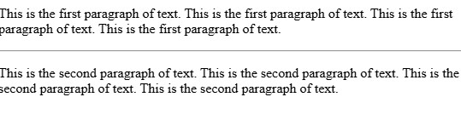

Line Break
<br> Tag
The <br> tag inserts a single line break.
The <br> tag is useful for writing addresses or poems.
The <br> tag is an empty tag which means that it has no end tag.
Example
<h1>A Poem</h1>
<p>Be not afraid of greatness.<br> Some are born great,<br> some achieve greatness,<br>
and others have greatness thrust upon them.</p>
<p><em>-William Shakespeare</em></p>


HTML Tables
HTML tables allow web developers to arrange data into rows and columns.

Syntax of HTML Table
<table>
// table content
</table>

Key Elements of HTML Table
• | <table>: Defines the table itself.
• | <tr>: Used for table rows.
• | <th>: Used for table headings.
• | <td>: Used for table cells (data).

Basic Table Structure
<table border='1'> <tr>
<th>Name</th>
<th>Age</th>
</tr>
<tr>
<td>John</td>
<td>27</td>
</tr>
<tr>
<td>ALice</td>
<td>37</td>
</tr>
<tr>
<td>Daisy</td>
<td>32</td>
</tr>
</table>
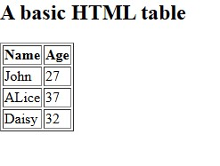

rowspan and colspan Attributes
rowspan
Rowspan: If you want a table cell to span multiple rows, you can use the attribute.
Colspan:
the | colspan
If you want a table cell to span multiple columns, you can use attribute.
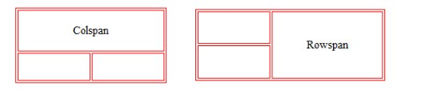
<table border="1">
<tr>
<td colspan="2">Merged Columns</td>
</tr>
<tr>
<td>Column 1</td>
<td>Column 2</td>
</tr>
</table>
HTML Forms
HTML forms are essential for collecting user input on web pages. Whether it's a search bar, a login screen, or a multi-field registration form.
They enable users to submit data, which can be processed, stored, or returned by a server.
HTML Forms Structure:
<form action="/action_page.php">
<label for="fname">First name:</label><br>
<input type="text" id="fname" name="fname" value="John"><br>
<label for="lname">Last name:</label><br>
<input type="text" id="lname" name="lname" value="Doe"><br><br>
<input type="submit" value="Submit">
</form>
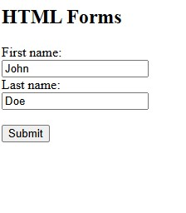
The <form> Element
The HTML <form> element is used to create an HTML form for user input:

The <input> Element
<input>
The tag is commonly used to create form controls. The attributes of this tag define the control's behavior.
The "type" attribute specifies the type of input control (e.g., text, password, checkbox).
The "name" attribute is used for identifying the control, especially when the data is sent to the server.
The "value" attribute sets a default value for the control, which the user can overwrite.
This is a versatile self-closing tag used to create various input fields. Its behavior is determined by the type attribute. Common type values include:
- text: For single-line text input.
- password: For password input (characters are masked).
- email: For email address input (provides basic validation and optimized keyboard on mobile).
- checkbox: For selecting multiple options.
- radio: For selecting a single option from a group.
- submit: Creates a button to submit the form.
- button: Creates a generic clickable button.
- hidden: For data that needs to be submitted but not visible to the user.

HTML <meta> Tag
- The <meta> tag defines metadata about an HTML document. Metadata is data (information) about data.
- <meta> tags always go inside the <head> element, and are typically used to specify character set, page description, keywords, author of the document, and viewport settings.
- Metadata will not be displayed on the page, but is machine parsable.
- Metadata is used by browsers (how to display content or reload page), search engines (keywords), and other web services.

Attributes
Attribute | Value | Description
charset | character_set | Specifies the character encoding for the HTML document
content | text | Specifies the value associated with the http-equiv or name attribute
http- | content-securitypolicy | Provides an HTTP header for the information/value of the content attribute
equiv | content-type default-style refresh
name | application-name author description generator keywords viewport | Specifies a name for the metadata

Example
<head>
<meta charset="UTF-8">
<meta name="description" content="Free Web tutorials">
<meta name="keywords" content="HTML,CSS,XML,JavaScript">
<meta name="author" content="John Doe">
<meta name="viewport" content="width=device-width, initialscale=1.0"> </head>

HTML frameset Tag
Not Supported in HTML5.
The <frameset> tag was used in HTML 4 to define a frameset.
The HTML <frameset> tag was used in older versions of HTML to create multipane layouts within a web page. By dividing the browser window into multiple sections, each frame could display a separate HTML document. This allowed for the creation of complex web layouts with different content in each pane.
Syntax
<frameset cols="pixels|%|*">
<!-- Define frames here -->
</frameset>
Attributes
The list of frameset attributes is given below:
Attribute | Description
cols | Defines the number of columns and their size within the frameset tag, creating vertical frames in the web browser.
rows | Defines the number of rows and their size within the frameset tag, creating horizontal frames in the web browser.
border | Specifies the width of the border of each frame in pixels. A value of 0 indicates no border.
frameborder | Specifies whether a three-dimensional border should be displayed between frames. Values: 0 (no border) or 1 (border).
framespacing | Specifies the amount of spacing between frames in a frameset, denoted in pixels.
Image Formats
Image formats are different types of file types used for saving pictures, graphics, and photos.
Common formats include JPEG, PNG, GIF, and SVG, each with its own strengths.
Image Format describes how data related to the image will be stored. Data can be stored in compressed, Uncompressed, or vector format.
JPEG (.jpg, .jpeg):
Joint Photographic Experts Group is a loss-prone (lossy) format in which data is lost to reduce the size of the image. Due to compression, some data is lost but that loss is very less.
GIF (.gif):
GIF or Graphics Interchange Format files are used for web graphics. They can be animated and are limited to only 256 colors, which can allow for transparency.
GIF files are typically small in size and are portable.
PNG (.png):
PNG or Portable Network Graphics files are a lossless image format. It was designed to replace gif format as gif supported 256 colors unlike PNG which support 16 million colors.

CSS
CSS is a stylesheet language that describes the presentation of an HTML (or XML) document.
CSS describes how elements must be rendered on screen, on paper, or in other media What is CSS?
- CSS stands for Cascading Style Sheets
- CSS describes how HTML elements are to be displayed on screen, paper, or in other media
- CSS saves a lot of work. It can control the layout of multiple web pages all at
once
- External stylesheets are stored in CSS files
Why Use CSS?
CSS is used to define styles for your web pages, including the design, layout and variations in display for different devices and screen sizes.
CSS Syntax:
A CSS rule-set consists of a selector and a declaration block:
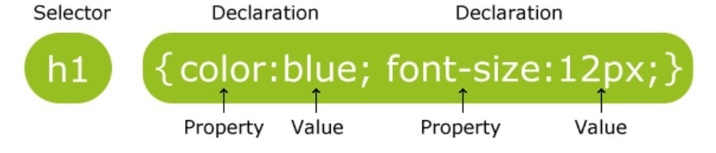
- The selector points to the HTML element you want to style.
- The declaration block contains one or more declarations separated by semicolons.
- Each declaration includes a CSS property name and a value, separated by a colon.
- A CSS declaration always ends with a semicolon, and declaration blocks are surrounded by curly braces.

Three Ways to Insert CSS
Styling can be added to HTML elements in 3 ways:
- Inline - using a style attribute in HTML elements • Internal - using a section
- External - using one or more external CSS files

Inline Styling (Inline CSS)
Inline styling is used to apply a unique style to a single HTML element: Inline styling uses the style attribute.
Example

Internal Styling (Internal CSS)
Internal styling is used to define a style for one HTML page.
Internal styling is defined in the section of an HTML page, within a
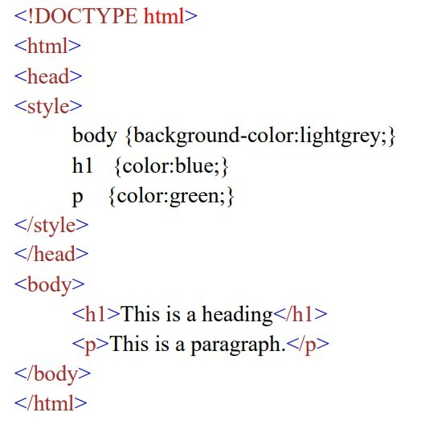

External Styling (External CSS)
An external style sheet is used to define the style for many pages. With an external style sheet
To use an external style sheet, add a link to it in the section of the HTML page:
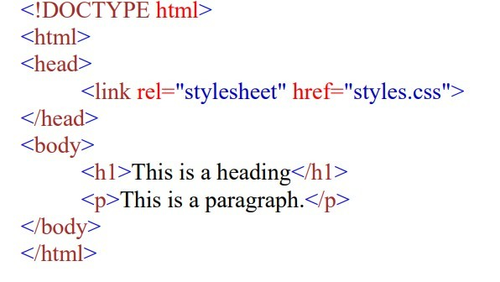

Style.css

Feature | Inline CSS | Internal CSS | External CSS
Location | It is used within HTML tag using the style attribute. | It is used within  <head> section of HTML document. | It is used in a separate .css file.
Selector Scope | Affects a single element or a | Affects multiple elements within the | Affects multiple HTML documents or an

 | group of elements. | same HTML element. | entire website.
Reusability | Not reusable. Styles need to be repeated for each element. | Can be reused on multiple elements within the same  HTML document. | Can be reused on multiple HTML documents or an entire website.
Priority | Highest priority. Overrides internal and external styles. | Medium priority. Overrides external styles but can be overridden by inline styles. | Lowest priority. Can be overridden by both inline and internal styles.
File Size | Inline styles increase the HTML file size, which can affect the page load time. | Internal styles are part of the HTML file, which increases the file size. | External styles are in a separate file, which reduces the HTML file size and can be cached for faster page loads.
Maintainability | Not easy to maintain. Changes need to be made manually to each element. | Relatively easy to maintain. Changes need to be made in one place in the <head> section. | Easiest to maintain. Changes need to be made in one place in the external .css file.

